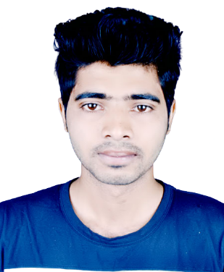

CURRICULUM VITAE

**OF**

**SAZIDUL RAHMAN**

MOBILE: 01708-332526

**Career Objective:** To build my career in any private and development organization by excellent blending of my academic and personal knowledge, integrity, skills and hard work that will add value to that respective organization and to contribute in the welfare and development for the organization as well as myself.

# Employment History

Organization : **Golden Hervest Infotech Ltd.**

Position : Data Entry Operator.

Duration : 1 Years (12th February, 2024 to 30th January, 2025)

Organization : **Coderoid IT Institute**

Position : Receptionist.

Duration : 24th March ,2023 to 30th December, 2023.

Duties and Responsibilities:

* Perform a variety of cleaning activities such as sweeping, mopping, dusting and polishing.
* Ensure all rooms are cared for and inspected according to standards.
* Protect equipment and make sure there are no inadequacies.
* Notify superiors on any damages, deficits and disturbances.
* Deal with reasonable complaints/requests with professionalism and patience.
* Check stocking levels of all consumables and replace when appropriate.
* Adhere strictly to rules regarding health and safety and be aware of any company related practices.

# Academic Qualifications:

* **Higher Secondary Certificate(H.S.C):**
* Institution : Katunia Rajbari Degree College
* Group : Humanities
* Result : GPA-4.25
* Board : Jessore

# Diploma in Engineering (Diploma):

* Institution : Satkhira Government Polytechnic Institute
* Group : Computer Science and Technology
* Result : CGPA-3.57
* Board : Technical

# Skills :

# Professional Computer Skills: Familiar with MS Office,

# internet browsing, email, etc.

# Communication: Strong verbal and written communication

# skills.

# Teamwork: Ability to collaborate and work effectively in

# team settings.

# Professional Appearance: Ability to maintain a well-

# groomed, professional look

# Language Proficiency:

Bangla : Mother tongue

English : Considerably speaking & writing in English

# Personal Details:

Name : Sazidul Rahman

Father’s Name : Nazraul Isalam

Mother’s Name : Sakina Khatun

Present Address : Nikunjo-2, Khilkhet, Dhaka-1212.

Permanent Address : Satkhira Sader, Khulna, Bangladesh

Date of Birth : 30/01/2001

Marital Status : Unmarried

Religion : Islam

Gender : Male

National ID No : 9169471035

# Reference :

# Emon Hasan

Manager, Coderoid IT Institute

Mobile- 01568-382780

I, the undersigned declare that information provide in the resume is true to the best of my belief andcorrectly describe my qualification and myself.

**Saziul rahman Date: ....................**